Recently found links that could be very helpful
https://blog.belimo.com/blog/cooling-with-ice-storage

Feb 26 - Background research summary due

ENGINEERING VILLAGE=: http://libaccess.sjlibrary.org/login?url=https://www.engineeringvillage.com/home.url?acw=

Notes from literature review videos (I think we should keep this in mind but idk if we need to directly fit into the chronological vs methodological box)
Parts of a literature review section:
Thesis statement, introduction, body, conclusion

Thesis statement argues for a particular perspective on material. (EX The current trend in technology…. )

Introduction: How we are approaching the literature review. (Either chronologically, thematically, or methodologically)

Body: If chronologically, present developments in technology in order. Methodologically, describe different ways researchers have approached your project. Thematically, describe pro and con of controversy (not applicable to us)
Don’t rely too heavily on extensive quotes
Give citations, stay on topic, stay organized

Conclusion: What learned from reviewing the literature

The requirements from the assignment
The summary should be two pages (single-space, 12-point font) long (approximately) and should include the following:

1. What are the various studies/resources informing your project?
- Covered by all the topics

2. What is the current state of the art?
- Current refrigerator designs, current high efficiency refrigerators and how they differ, current passive cooling methods

3. What are some of the gaps your project is trying to fill? Or how will your project advance the current technology?
- Cover in conclusion paragraph(s) as well as introduce in introduction paragraph

Current technology:
- Current refrigerator designs (particularly mini) (Kalino)
  - Examples of refrigerant diagrams/interior structure models
  - What materials they use
  - What refrigerant they use (rly good source since shows environmental effects for each as well)
  - What size of components
  - Size of shell
  - What is the typical energy usage
  - What can we use to compare efficiency values
- Refrigerator insulation materials (Brent)
  - What is typically used?
  - How much does it cost?
  - Where can we buy it from?
  - Are there ways to 3D print plastic/rubber components?
  - Foam spray or boards, and pre-made insulation panels can be purchased. It is not common practice to 3D print these components; however, 3D printing thermoplastics with less insulating properties is possible. The foam or pre-made panels can be purchased from places like amazon and home depot, and we can use one of these items combined with a 3D printed shell to create our working prototype. For a cheap but effective strategy, we can wrap panels in foil for an increase in thermal resistance. If we want to improve efficiency, we can also opt for the improved materials listed below.
- High efficiency refrigerators (Brent)
  - Are there high efficiency models out there that are marketed to be more energy efficient?
  - What is different about them?

Constructability Category (CALEB):
- How to construct refrigerator/refrigeration cycle from scratch
- How do you buy refrigerant
  - https://www.epa.gov/section608/refrigerant-sales-restriction
    - Requires Certified Technicians, EPA policy section 208 and 209
  - https://iwae.com/resources/articles/r-410a-questions-answers/#:~:text=Do%20you%20need%20a%20license,to%20a%20trained%20HVAC%20professional.
    - Can buy R-410A without a permit, but need a permit to charge the system
  - https://www.sciencedirect.com/science/article/pii/S0263224108001930 “Efficiency analysis of home refrigerators by replacing hydrocarbon refrigerants”
  - asd

- DIY how to pressurize/load the refrigerant
  - https://theengineeringmindset.com/design-a-refrigeration-system/
    - 4 important points need to know data values (temperature, pressure, enthalpy and entropy
    - Includes equations for work done at the condenser, evaporator and how to find the COP
  - https://www.sciencedirect.com/science/article/abs/pii/S1359431114001999 “The effect of selecting proper refrigeration cycle components on optimizing energy consumption of the household refrigerators”
  - https://www.sciencedirect.com/science/article/pii/S1359431117354674 “Review: Recent advances in household refrigerator cycle technologies”

- Types of ways to create airtight seals
  - https://www.greenbuildingadvisor.com/question/techniques-products-for-hard-core-stock-exterior-door-air-sealing
  - https://www.greenbuildingforum.co.uk/newforum/comments.php?DiscussionID=13047

Mechatronics Category: M
- What kinds of sensors are used in refrigerators
  - https://elementalmachines.com/resources/which-temperature-sensors-are-used-in-industrial-refrigerators/
- What are the typical controls used in standard refrigerators
- What are smart controls used in high efficiency refrigerators
- How often do we want to the data collection/sensor outputs to run

Calculations category (Isabel)
- What types of calculations will we need to use to estimate heat transfer (Isabel)
- What models we can make for heat transfer (Isabel)
- What calculations will we need to do for power requirements (Isabel)
- Determining COP/Carnot approx
- (Check out the calculations sheet in drive)

Passive Cooling Category (Isabel)
- What are passive cooling appliances that exist
- Sources:
  - History of comfort cooling using Ice from ASHRAE
    - Nagengast, B. (1999). A History of Comfort Cooling Using Ice. ASHRAE Journal.
  - Passive refrigerator (Using outdoor cool air)
  - History of ice to electric refrigeration
  - Removed from writing to shorten:
There are two distinct uses of passive cooling: comfort cooling and food preservation. The least complex methods of passive cooling for comfort include creating openings for cross ventilation, moving air over wet surfaces to cause heat to be absorbed by evaporation, and shading structures. The development of more elaborate comfort cooling systems utilizing thermal mass began in the mid 1800s. In 1864, the first cooling system in the U.S. was proposed by George Knight who designed a heat exchanger that cooled air using a cooling coil with contained blocks of ice (Nagengast, 1999). This method was effective in lowering the temperature, though was flawed in the increase of humidity. Further models implemented drying using desiccant to improve the comfort of the air.

  - https://iopscience.iop.org/article/10.1088/1755-1315/1256/1/012005/pdf
  - Lunch box with 20% saltwater as PCM
  - Not credible post:
  - 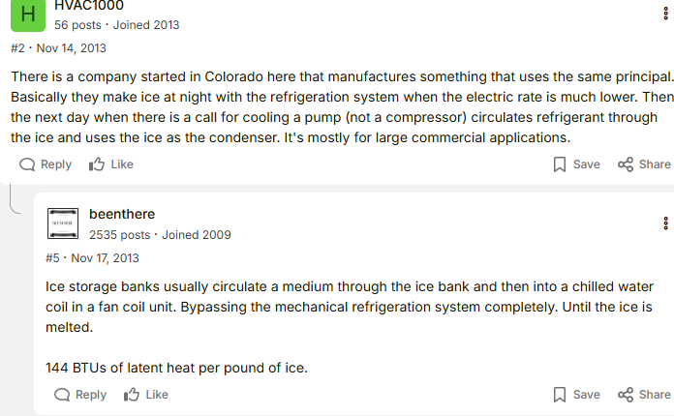

https://www.sciencedirect.com/science/article/pii/S0140700719305249?casa_token=aMSeblUJgmQAAAAA:pFknpIVx0wpMFw9cM0ox9X8VyOV6mrrh0pbJALBrNCBzJRLs4jmWwbPV87G7nvOGwvNDVfVANIU
Refrigerators use Polyurethane for their insulation

https://www.webstaurantstore.com/article/474/refrigerant-types.html
Refrigerant types

https://www.proquest.com/docview/2785245556/fulltextPDF?accountid=10361&parentSessionId=nMZvx7%2FMhnOx3bFz7SQ991lrY%2BbJL%2Bu23Emuw2ZNMlg%3D&pq-origsite=primo&sourcetype=Scholarly%20Journals
Mini fridge energy use for students

https://www.energybot.com/electricity-rates/
Energy rates

Mar 5 - Project Proposal Presentation
Basic Sales Pitch Presentation

Mar 19 - Design Specification
Sketches

Mar 26 - Idea Summary
Clear project proposal?

Apr 9 - Midterm Report
Apr 16 - Design calculations
CAD mostly finished

Apr 23 - Simulations and design feasibility
FEA completed
Apr 30 - BOM, economic analysis
May 12 - Final Report

Here’s the list from proposal
Steps/components of the project (Not necessarily in consecutive order)
- Research existing technology:
  - Current refrigerator designs
  - Refrigerator insulation materials
  - High efficiency refrigerators
  - Types of refrigerant
- Create CAD model of refrigerator design
- Perform calculations using Matlab or Python script to calculate:
  - Heat transfer in all parts of the refrigerator
  - Force and stress of fridge door (hinges)
  - Power requirements
- Design refrigeration cycle and choose proper components (compressor, fans, etc)
  - Must consider that the cold reservoir ice will melt into water that must be collected and refrozen
- Implement sensors, circuitry, microcontroller, and code to monitor temperatures and control the passive/active modes
- Using the sensors, analyze the performance of the refrigerator to determine the success of our design

